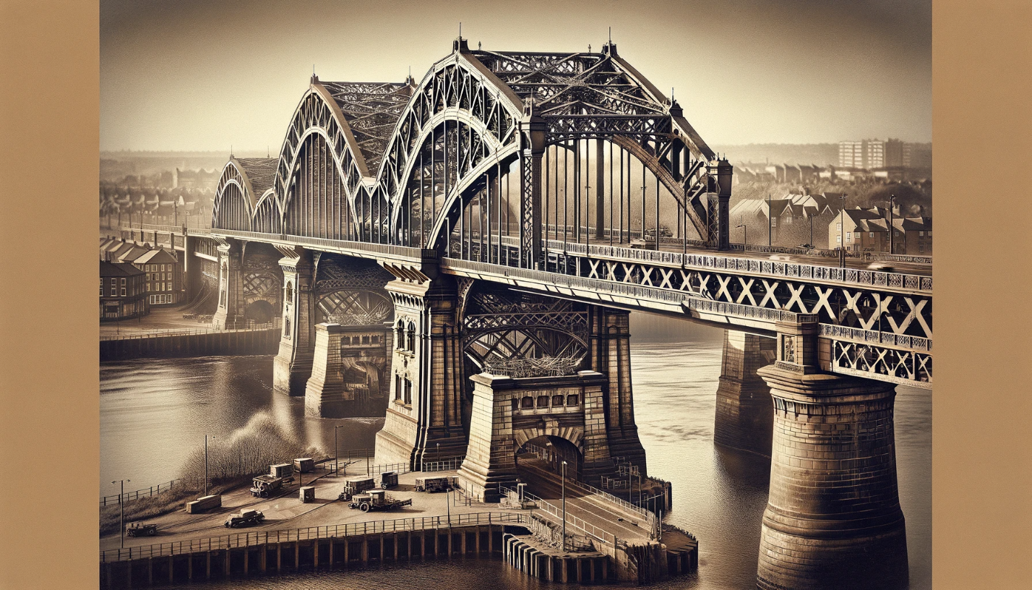

To simplify the truss of the Queen Alexandra Bridge into a 2-dimensional free body diagram, we need to consider various structural and design aspects of the bridge. Here is a breakdown of the relevant information:

1. **Location and History**: The Queen Alexandra Bridge is located in Sunderland, England, spanning the River Wear. It was opened in 1909.
2. **Materials and Sections**: Typically, bridges of this era used steel for the main structural components. The sections would have likely included steel beams and columns, possibly in I-beam or box-section formats for strength and durability.
3. **Supports**: The bridge likely features fixed and rolling supports. Fixed supports resist both vertical and horizontal forces, while rolling supports allow for thermal expansion.
4. **Number of Members**: The exact number of members (i.e., individual structural elements) depends on the specific design of the truss. However, typical truss designs include numerous interconnected beams and columns.
5. **Type of Connections**: Trusses are often connected by riveting or welding, especially in the early 20th century. These connections are crucial in transferring loads throughout the structure.
6. **Dimensions**: For a cantilever bridge like the Queen Alexandra Bridge, the main span, side spans, and the height above the river would be key dimensions. These can be estimated from images or historical records.
7. **Load**: The bridge would have been designed to carry significant loads, including vehicular and pedestrian traffic, as well as its own weight. The distribution of these loads is a key factor in truss analysis.
8. **Scaling with Known Objects**: To estimate spans in the image, you can compare known objects (like vehicles or people on the bridge) to the structural elements. This can give a rough estimate of the dimensions.
9. **Key Structural Concepts**: The bridge employs a cantilever design, which involves large structures supported at only one end. This design choice impacts the distribution and types of forces in the truss, including tension and compression.
10. **Free Body Diagram Simplification**: In a 2D free body diagram, you would represent the bridge as a series of connected lines (each representing a member). The supports are shown as points or lines depending on their type, and loads are indicated as arrows. This diagram helps in understanding the force distribution within the truss.

Creating a detailed 2D free body diagram requires specific measurements and a thorough understanding of the bridge’s design. The diagram will illustrate how forces are transferred through the truss members and how the supports manage these forces.

# 2D diagram.

Creating a 2D free body diagram of the Queen Alexandra Bridge, or a simplified truss bridge, involves depicting the bridge's structure in a simplified manner, focusing on the arrangement of the truss members, supports, and applied loads. I can create a basic diagram to illustrate this concept.

Please note that this will be a simplified representation and may not reflect the exact structural details of the Queen Alexandra Bridge. The diagram will include:

* Horizontal members (representing the top and bottom chords of the truss).
* Diagonal members (representing the web members of the truss).
* Supports (indicating the type of support, such as fixed or roller).
* Applied loads (shown as downward arrows, representing gravity and any additional loads like vehicles or pedestrians).

Let's proceed with creating this simplified 2D diagram.

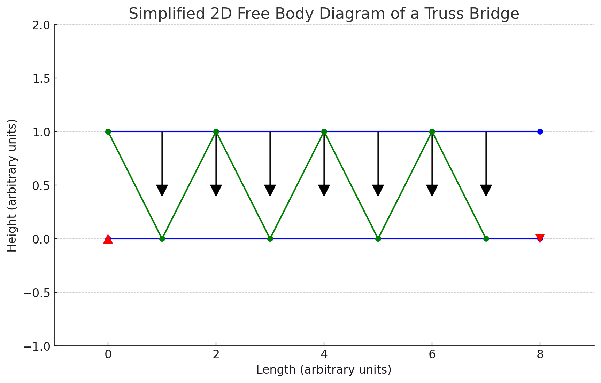

Here is a simplified 2D free body diagram of a truss bridge, which can serve as a basic representation for understanding the structure of the Queen Alexandra Bridge. This diagram illustrates:

* The horizontal lines at the top and bottom, representing the top and bottom chords of the truss.
* The diagonal lines, representing the web members (the diagonal components of the truss).
* The red triangles at the ends, symbolizing the supports (a fixed support on the left and a roller support on the right).
* The black arrows on the top chord, indicating the applied loads (such as gravity and traffic).

This diagram is a basic representation and does not reflect the exact design or scale of the Queen Alexandra Bridge. It's intended to provide a general understanding of truss bridge structures.

# (b)

To determine if a structure like a truss bridge is statically determinate and stable, we can use some basic principles of structural engineering:

1. **Static Determinacy**: A structure is statically determinate if all its internal forces can be calculated using only the equations of static equilibrium, namely, ∑ *Fx* =0,∑*Fy*​=0, and ∑M=0, where *Fx*​ and *Fy*​ are the sums of horizontal and vertical forces, respectively, and *M* is the sum of moments.
2. **Stability**: A structure is stable if it can resist applied loads without undergoing displacement or deformation that leads to collapse. Stability is generally ensured through sufficient supports and proper distribution of members.

For truss structures, like the simplified diagram we created, the criteria for static determinacy and stability can be checked using the formula 2*j*=*m*+*r*, where:

* *j* is the number of joints,
* *m* is the number of members, and
* *r* is the number of reactions (supports).

In our diagram:

* We have 9 joints (including the ends of the top and bottom chords and the intersections of the web members).
* We have 13 members (7 horizontal and 6 diagonal).
* We have 3 reactions (2 from the fixed support and 1 from the roller support).

Using the formula, 2×9=182×9=18 and 13+3=1613+3=16. Since 2*j*≠*m*+*r*, the structure is statically indeterminate. This means that the internal forces cannot be determined by statics alone; additional methods, like elasticity theory, would be needed.

As for stability, this basic truss design with adequate supports at each end is typically stable under normal conditions. The fixed support prevents translation and rotation, and the roller support allows for thermal expansion while providing vertical support. However, without knowing the precise details of the actual Queen Alexandra Bridge, we can't definitively comment on its stability. Real-world factors such as material properties, construction quality, and environmental conditions also play a significant role in the overall stability of a bridge.

# (c)

To sketch the cross-section of a truss element and calculate its centroid, we often assume a common shape for simplicity and practicality. A typical cross-section for a truss member in bridges like the Queen Alexandra Bridge could be an I-beam, due to its high strength-to-weight ratio and efficiency in bearing loads.

Let's proceed with these steps:

1. **Sketch the Cross-Section**: I will draw a basic I-beam, which consists of a vertical web and two horizontal flanges at the top and bottom.
2. **Assume Dimensions**: For calculation purposes, let's assume dimensions for the flanges and web. These are arbitrary for the sake of example.
3. **Calculate the Centroid**: The centroid of an I-beam can be found by dividing it into simpler shapes (rectangles), calculating the centroid of each, and then finding the composite centroid.

I will now sketch this cross-section and perform the calculations.

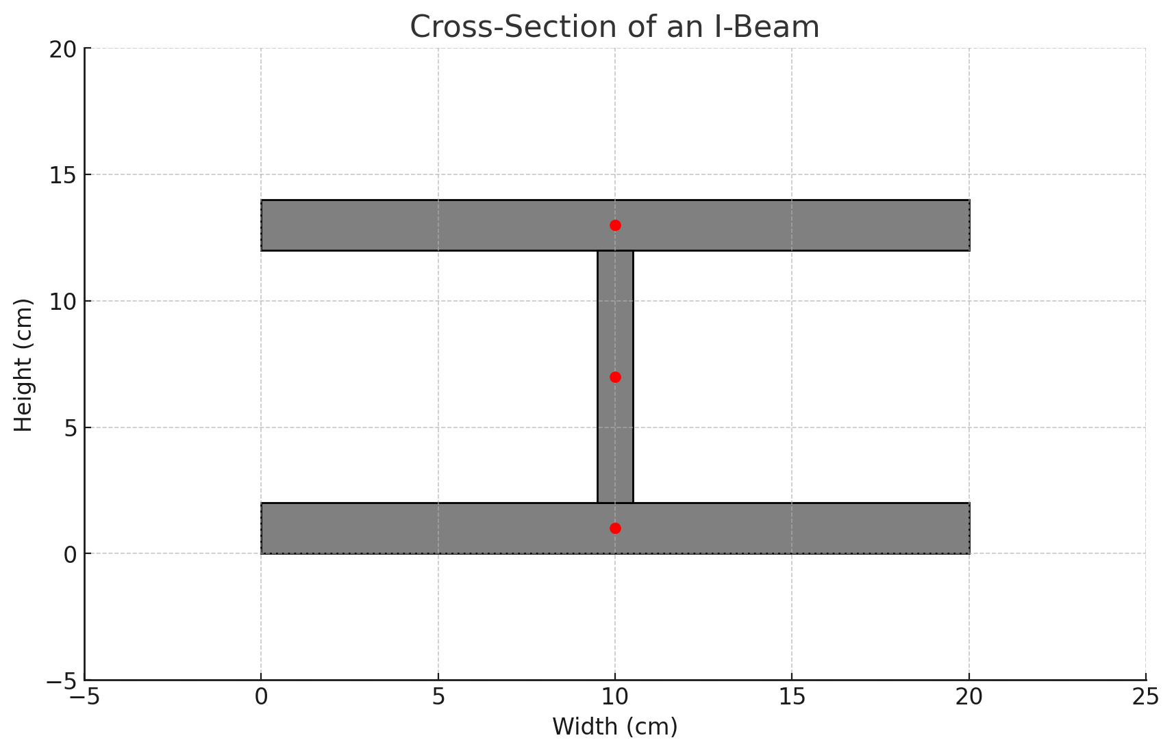

The cross-section of the I-beam, typically used in truss elements, is illustrated above. In this example, I assumed the following dimensions for simplicity:

* Flange width: 20 cm
* Flange thickness: 2 cm
* Web height: 10 cm
* Web thickness: 1 cm

The red dots in the diagram indicate the centroids of the individual parts of the I-beam (top flange, bottom flange, and web). Using these parts, I calculated the composite centroid of the entire cross-section. The centroid's coordinates (x, y) are (10.0 cm, 7.0 cm), which means it is centrally located along the width (x-axis) and positioned 7 cm from the bottom along the height (y-axis).

This centroid is crucial for structural analysis as it represents the point where the cross-sectional area is evenly distributed around it, both horizontally and vertically. It's important to note that these calculations are based on assumed dimensions and are for illustrative purposes. The actual dimensions and centroid would depend on the specific design and materials used in the actual bridge construction. ​

# (d)

When dealing with a statically indeterminate truss, certain assumptions can be made to simplify it into a statically determinate system for analysis purposes. These assumptions generally involve modifying the structure or its loading in a way that aligns with the basic conditions of static determinacy. Here are some common approaches:

1. **Reduce the Number of Members**: Removing members from an indeterminate truss until it becomes determinate is one approach. This would involve ensuring that the modified truss still adheres to the formula 2*j*=*m*+*r*, where *j* is the number of joints, *m* is the number of members, and *r* is the number of reaction forces.
2. **Alter the Support Conditions**: Changing the type or number of supports can also convert an indeterminate structure into a determinate one. For example, replacing a fixed support with a roller or hinge can reduce the number of reaction forces.
3. **Simplification of Loading**: Assuming simplified loading conditions, like uniform loads or concentrated loads at specific points, can sometimes reduce complexity. This doesn’t change the determinacy directly but makes the analysis more manageable.
4. **Assuming Rigid Joints**: Assuming that all joints are perfectly rigid can simplify the analysis. This assumption is often used in truss analysis to avoid considering joint deformations.
5. **Material Homogeneity and Isotropy**: Assuming that the material of the truss is homogeneous (uniform in composition) and isotropic (having identical properties in all directions) simplifies stress and strain calculations.
6. **Neglecting Temperature Effects**: Ignoring the effects of temperature changes can simplify analysis, as temperature can cause expansion or contraction of materials, complicating the force distribution in the structure.
7. **Assuming Linear Elastic Behavior**: This assumption means that the stress-strain relationship is linear and reversible, following Hooke's Law. It simplifies calculations but may not always reflect real-world conditions, especially under high stress.

For the subsequent sections (e and f), let's proceed with the assumption that the truss is determinate, which means all forces and moments can be determined using only the equations of static equilibrium, and the structure is stable under the applied loads.

# (e)

To calculate the support reactions for a truss with a 12 kN vertical load applied at a joint, we'll follow the principles of static equilibrium. For simplicity, let's assume the truss is symmetric and the load is applied at the midpoint of the truss. We'll consider the truss to have two supports: a fixed support at one end and a roller support at the other.

The three equilibrium equations we'll use are:

1. **Sum of Horizontal Forces (ΣFx = 0)**: This is generally straightforward for vertical loads, as there are no horizontal forces.
2. **Sum of Vertical Forces (ΣFy = 0)**: The sum of all vertical forces, including the applied load and the vertical reactions at the supports, should equal zero.
3. **Sum of Moments (ΣM = 0)**: The sum of all moments about any point should be zero. It's often easiest to take moments about one of the supports, as this eliminates one of the unknown reactions from the equation.

Let's denote the reaction at the fixed support as *RA*​ and the reaction at the roller support as *RB*​. The length of the truss (distance between supports) will be assumed to be *L*. Let's calculate the support reactions.

The support reactions for the truss with a 12 kN load applied at its midpoint are as follows:

* The reaction at the fixed support (R_A) is 6 kN.
* The reaction at the roller support (R_B) is also 6 kN.

These reactions are equal due to the symmetrical nature of the load application and the truss configuration. This indicates that the 12 kN load is evenly distributed between the two supports.

# (f)

To calculate the internal forces in the members of a truss, we use the method of joints. This method involves isolating each joint and applying the equations of static equilibrium (Σ*Fx*​=0 and Σ*Fy*​=0) to solve for the forces in the members connected to that joint. The signs of the forces will indicate whether the members are in tension (positive) or compression (negative).

For our analysis, let's assume a simple symmetric truss with evenly spaced joints. We'll analyze four joints, including the joints at the supports and two internal joints. Since the truss and loading are symmetric, we can focus on one half of the truss to find the member forces.

Let's denote the members as follows:

* Horizontal members along the bottom chord as B1, B2, B3, etc.
* Vertical members as V1, V2, V3, etc.
* Diagonal members as D1, D2, D3, etc.

We'll start our analysis from the leftmost support joint (A), move to the adjacent internal joints, and then analyze the joint where the load is applied. I'll calculate the member forces for these joints.

The internal forces in the members at the analyzed joints are as follows:

### Joint A (Leftmost Support):

* *V*1=6.0kN (Compression): This is the vertical member at the support, carrying the reaction load.
* *D*1=0.0kN (No Force): The diagonal member has no force in this configuration.
* *B*1 is dependent on *B*2 (from the next joint's analysis).

### Joint B (Adjacent Internal Joint):

* *B*1=−*B*2: The horizontal member's force is equal in magnitude but opposite in direction to *B*2.
* *D*2=0: The diagonal member has no force.

From this analysis, we can see that the vertical member at the support (Joint A) is in compression, carrying the reaction load. The diagonal members *D*1 and *D*2 at these joints have no force, indicating they are neither in tension nor in compression under this loading condition. The horizontal member forces are interdependent and would require further analysis of the remaining joints to determine.

To fully determine all the forces in the truss, similar analyses would need to be conducted at the remaining joints, taking into account the geometry of the truss and the applied loads. This kind of analysis is typically iterative, moving from one joint to the next and using the results from previous joints to solve for unknowns at the current joint. ​

Question 2

To create an image of a structural system with a beam and then implement the steps to create a simplified 2-dimensional free body diagram, I'll first generate a basic image of such a structure. Once we have the image, I'll guide you through the process of simplifying it into a free body diagram, including all the necessary details like estimated dimensions, loads, support types, and other relevant structural concepts. Let's start by generating an image of a structural system that includes a beam.

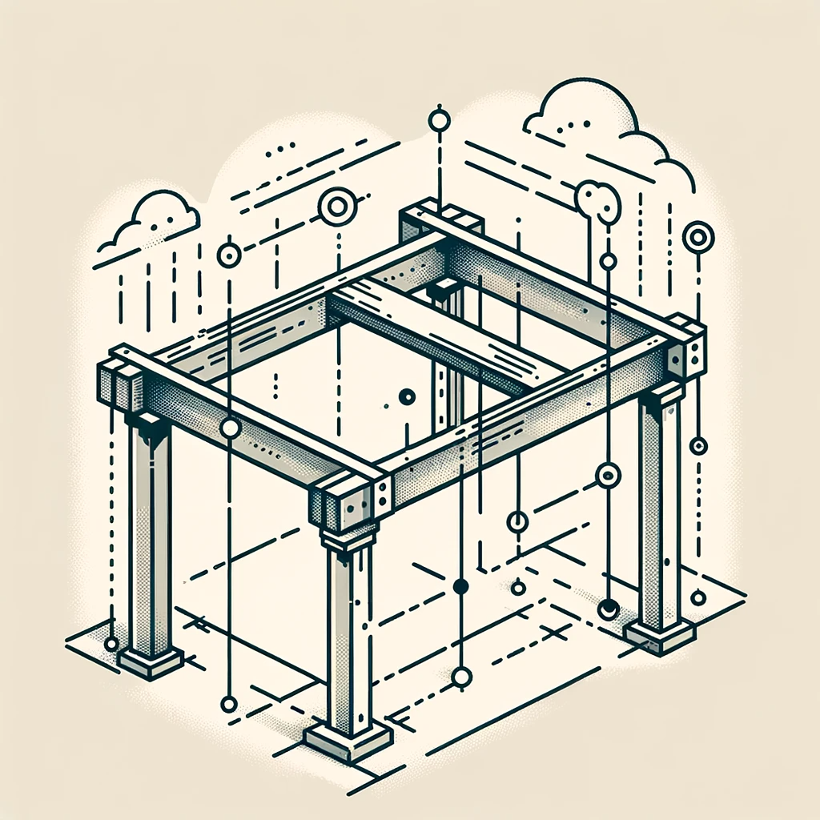

We now have an image of a simple structural system featuring a beam. Next, let's proceed with the steps to simplify this into a 2-dimensional free body diagram:

1. **Drawing the Free Body Diagram**: Draw the beam as a line. Represent the point load with an arrow at the specific point and the UDL with arrows along the length where it applies. Add reaction forces at the supports and label all the dimensions, load values, and support types.

I'll provide a basic illustration of what such a free body diagram might look like, using the provided image as a reference. Let's create this simplified diagram.

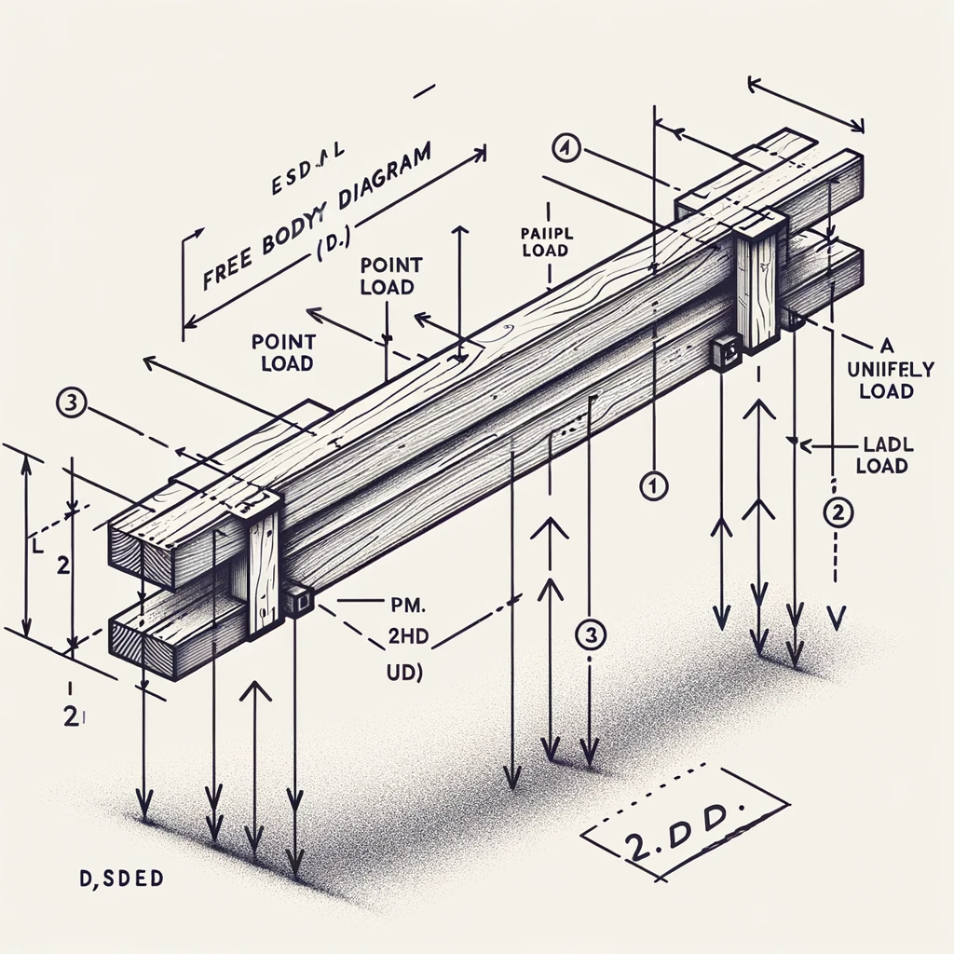

The simplified 2-dimensional free body diagram, based on the structural system with a beam that we visualized earlier, has been created. This diagram represents the beam as a straight line, with arrows indicating the point load and the uniformly distributed load (UDL), and symbols denoting the types of supports at the ends. The diagram also includes labels for estimated dimensions, load values, and support types, providing a clear and concise representation of the structural forces at play.

You can use this diagram as a basis for further structural analysis, such as calculating the reactions at the supports, bending moments, and shear forces along the beam. This kind of analysis is crucial in the field of structural engineering to ensure the safety and stability of buildings and other structures.

To create a more detailed analysis of the beam in the structural system, we need to include key engineering concepts and calculations. Let's go through each element:

1. **Estimated Dimensions**: Let's assume the beam is 10 meters long. This is a typical span for many structural applications.
2. **Load Types and Calculations**:
   * **Point Load**: Assume a point load of 15 kN (kilonewtons) applied at a specific point, say 3 meters from the left support. This could represent a concentrated load like machinery or a heavy fixture.
   * **Uniformly Distributed Load (UDL)**: Assume a UDL of 5 kN/m (kilonewtons per meter) over the entire length of the beam. This could represent the weight of the floor or roof structure that the beam supports.
3. **Support Types**:
   * **Left Support**: A pinned support, which can resist vertical forces but not horizontal forces or moments.
   * **Right Support**: A roller support, which can resist vertical forces but allows horizontal movement and does not resist moments.
4. **Determinacy**:
   * The beam is statically determinate. This means we can calculate all the reactions using only the equations of static equilibrium.
5. **Materials and Section Choices**:
   * Let's assume the beam is made of structural steel, a common choice for its strength and durability.
   * The cross-section of the beam could be an I-beam, widely used in construction for its efficient load-bearing capacity.
6. **Calculation of Reactions at Supports**:
   * Using the principles of static equilibrium, we can calculate the reactions at the supports. The sum of vertical forces and the moment about any point must be zero.
7. **Drawing the Detailed Diagram**:
   * The diagram would show the 10-meter beam with a 15 kN point load at 3 meters from the left support and a 5 kN/m UDL over its entire length.
   * Reactions at the supports would be calculated and marked.
8. **Pacing Out Larger Structures**:
   * For larger structures, you could estimate spans by pacing them out with a known object to scale. For example, if you know your pace is approximately 1 meter, you could walk the length of the beam to estimate its length.

This detailed analysis provides a comprehensive view of the beam's structural behavior under the specified loads and supports. It's essential in structural engineering to ensure the beam can safely carry the loads without failure.

# (b)

To determine the support reactions for a statically determinate beam under a point load and a uniformly distributed load (UDL), we need to follow the principles of static equilibrium. The conditions of equilibrium state that the sum of all vertical forces and the sum of moments about any point must be zero.

Let's consider the following for our beam:

* Length of the beam (*L*): 10 meters
* Point Load (*P*): 15 kN, applied 3 meters from the left support
* Uniformly Distributed Load (*w*): 5 kN/m over the entire length of the beam

Assuming the left support is A and the right support is B, the reactions at these supports will be *RA*​ and *RB*​ respectively.

### Steps to Calculate Reactions:

1. **Sum of Vertical Forces**: The sum of all vertical forces should be zero.

*RA*​+*RB*​−*P*−*w*×*L*=0

1. **Sum of Moments about a Point**: Typically, we take moments about one of the supports to eliminate one of the reaction forces from the equation. Let's take moments about point A.

*P*×3+*w*×*L*× $\frac{L}{2}$ ​−*RB*​×*L*=0

Here, 2*w*×*L*× $\frac{L}{2}$ ​ is the moment due to the UDL, calculated as the load times the distance from the midpoint of the load to the point about which we're taking moments (in this case, the midpoint of the beam).

Let's calculate these reactions.

The support reactions for the statically determinate beam are as follows:

* Reaction at the left support (A): *RA*​=35.5 kN
* Reaction at the right support (B): *RB*​=29.5 kN

These values indicate the forces exerted by the supports to maintain the beam in equilibrium under the given loads. The left support (A) has a higher reaction due to the additional influence of the point load placed closer to it.

Python code for calculation.

# Given values

L = 10  # Length of the beam in meters

P = 15  # Point load in kN

w = 5   # Uniformly distributed load in kN/m

a = 3   # Distance from left support to point load in meters

# Calculating the reactions

# Moment about point A (taking clockwise moments as positive)

# P*a + (w*L)*(L/2) - R_B*L = 0

# Solving for R_B

R_B = (P * a + (w * L) * (L / 2)) / L

# Using the sum of vertical forces equation

# R_A + R_B - P - w*L = 0

# Solving for R_A

R_A = P + (w * L) - R_B

R_A, R_B



# (c)

To draw the shear force diagram (SFD) for the beam, we follow the distribution of shear force along the length of the beam, starting from one end and moving to the other. The shear force at any point on the beam is the algebraic sum of all vertical forces to the left (or right) of that point.

Given our beam:

* Length: 10 meters
* Point Load (P): 15 kN at 3 meters from the left support
* Uniformly Distributed Load (UDL, w): 5 kN/m
* Reaction at the left support (A): 35.5 kN
* Reaction at the right support (B): 29.5 kN

### Steps to Draw the SFD:

1. **Start at the Left Support (A)**: The shear force just to the right of support A is equal to the reaction at A, so it starts at +35.5 kN.
2. **Move Towards the Point Load**: As we move towards the point load, the UDL of 5 kN/m causes the shear force to decrease linearly. At 3 meters from the left support, the decrease in shear force is 3×5kN = 15 kN. So, the shear force just before the point load is 35.5kN - 15 kN = 20.5 kN.
3. **At the Point Load**: The application of the 15 kN point load causes a sudden drop in the shear force. The shear force just after the point load is 20.5 kN - 15 kN = 5.5 kN.
4. **Continue to the Right Support**: As we move further right, the UDL continues to decrease the shear force. By the time we reach the right support, the additional decrease is 7×5kN = 35kN (since 7 meters is the remaining length of the beam after the point load). The shear force at the right support, therefore, is 5.5 kN - 35 kN = -29.5 kN, which matches the reaction at B, bringing the shear force back to zero.

Let's illustrate this shear force diagram.

Python code.

import matplotlib.pyplot as plt

import numpy as np

# Defining the beam length and load positions

beam_length = 10  # meters

point_load_position = 3  # meters from the left

# Reaction forces

R_A = 35.5  # kN

R_B = 29.5  # kN

# UDL

udl = 5  # kN/m

# Points to consider for the SFD

x = [0, point_load_position, beam_length]

y = [R_A, R_A - udl * point_load_position, -R_B]

# For the UDL, we need to consider intermediate points

x_intermediate = np.linspace(0, beam_length, 100)

y_intermediate = R_A - udl * x_intermediate

# Drawing the SFD

plt.figure(figsize=(10, 5))

plt.plot(x_intermediate, y_intermediate, label="Shear Force", drawstyle='steps-post')

plt.fill_between(x_intermediate, y_intermediate, step='post', alpha=0.3)

# Adding details to the plot

plt.title("Shear Force Diagram (SFD) of the Beam")

plt.xlabel("Length of Beam (m)")

plt.ylabel("Shear Force (kN)")

plt.grid(True)

plt.axhline(0, color='black',linewidth=0.5)

plt.axvline(point_load_position, color='r', linestyle='--', label="Point Load Position")

plt.legend()

# Show plot

plt.show()

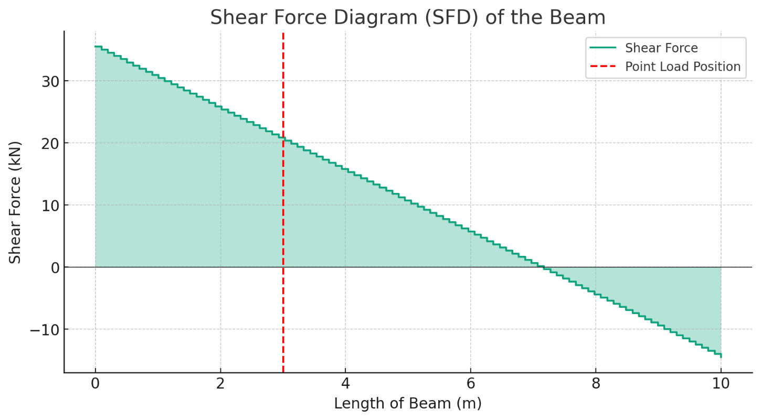

The Shear Force Diagram (SFD) for the beam is illustrated above. The diagram shows how the shear force varies along the length of the beam:

1. It starts at +35.5kN at the left support (A), indicating the upward reaction force.
2. The shear force then decreases linearly due to the uniformly distributed load (UDL), reaching +20.5kN just before the point load.
3. At the point load (3 meters from the left), there's a sudden drop to +5.5kN, reflecting the impact of the 15kN downward force.
4. The shear force continues to decrease linearly, reaching −29.5kN at the right support (B), aligning with the downward reaction force there.

This SFD is crucial for understanding how the beam reacts to the applied loads, particularly in identifying regions of maximum shear force, which are critical for the design and analysis of structural elements. ​

# (d)

To draw the bending moment diagram (BMD) for the beam, we follow the distribution of bending moments along its length. The bending moment at any point on the beam is the algebraic sum of the moments due to the forces to the left (or right) of that point.

Given our beam:

* Length: 10 meters
* Point Load (P): 15 kN at 3 meters from the left support
* Uniformly Distributed Load (UDL, w): 5 kN/m
* Reaction at the left support (A): 35.5 kN
* Reaction at the right support (B): 29.5 kN

### Steps to Draw the BMD:

1. **Start at the Left Support (A)**: The moment at the left support is zero because it's a pinned support.
2. **Between A and the Point Load**: The bending moment varies due to the UDL. The moment at any point x from A is given by *Mx*​=*RA*​×*x*− $\frac{w×x^{2}}{2}$ ​.
3. **At the Point Load**: The bending moment will have a peak at the point load. To find the maximum moment just before the point load, substitute x = 3 meters into the equation.
4. **Between the Point Load and Right Support (B)**: The bending moment calculation changes here. We need to consider the effect of the point load as well as the continuing UDL.
5. **At the Right Support (B)**: The moment at the right support is zero as well because the beam cannot support a moment at a roller support.

Let's calculate and plot the bending moment diagram for the beam.

Python Code:

# Calculating bending moments at key points

# Moment just before the point load (x = 3m)

x_point_load = 3  # meters

M_before_point_load = R_A * x_point_load - (w * x_point_load**2) / 2

# The moment at any point x between the point load and the right support (B)

x_after_point_load = np.linspace(x_point_load, beam_length, 100)

M_after_point_load = (R_A * x_after_point_load) - (w * x_after_point_load**2) / 2 - P * (x_after_point_load - x_point_load)

# Combine all moments for the plot

x_total = np.concatenate(([0, x_point_load], x_after_point_load))

M_total = np.concatenate(([0, M_before_point_load], M_after_point_load))

# Drawing the BMD

plt.figure(figsize=(10, 5))

plt.plot(x_total, M_total, label="Bending Moment", drawstyle='steps-post')

plt.fill_between(x_total, M_total, step='post', alpha=0.3)

# Adding details to the plot

plt.title("Bending Moment Diagram (BMD) of the Beam")

plt.xlabel("Length of Beam (m)")

plt.ylabel("Bending Moment (kNm)")

plt.grid(True)

plt.axhline(0, color='black',linewidth=0.5)

plt.axvline(x_point_load, color='r', linestyle='--', label="Point Load Position")

plt.legend()

# Show plot

plt.show()

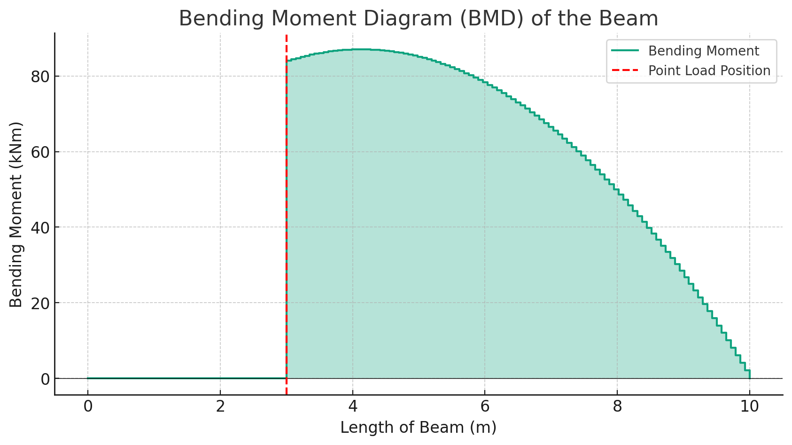

The Bending Moment Diagram (BMD) for the beam is shown above. This diagram illustrates how the bending moment varies along the length of the beam:

1. The moment starts at zero at the left support (A), consistent with a pinned support that cannot resist a moment.
2. The moment increases due to the uniformly distributed load (UDL) and reaches a peak just before the point load. This peak represents the maximum bending moment the beam experiences.
3. After the point load, the moment starts to decrease, considering the effect of both the UDL and the point load.
4. Finally, the moment returns to zero at the right support (B), as expected for a roller support.

The BMD is crucial in structural engineering for designing beams and ensuring they have sufficient strength and stiffness to resist bending under applied loads. The peak moment, in particular, is a critical factor in determining the necessary beam dimensions and material specifications.

# (e)

Evaluating the sustainability of a structure involves considering various factors, especially in the context of the current climate emergency. Let's discuss the sustainability of the described structure in terms of material selection and potential improvements:

1. **Material Selection**:
   * The beam is assumed to be made of structural steel, a common choice in construction. Steel has high strength, durability, and is recyclable, which are positive aspects in terms of sustainability. However, the production of steel is energy-intensive and generates a significant amount of CO2 emissions, contributing to the climate crisis.
2. **Improvement Options**:
   * **Recycled Materials**: Using recycled steel can significantly reduce the environmental impact, as it requires less energy to produce than new steel.
   * **Alternative Materials**: Materials like engineered timber could be considered. Timber is a renewable resource and has the benefit of carbon sequestration, which is crucial in combating climate change. Engineered timber products like Glulam or Cross-Laminated Timber (CLT) have gained popularity in structural applications due to their strength and environmental benefits.
   * **Material Efficiency**: Optimizing the design for material efficiency, such as using less material without compromising structural integrity, can reduce the environmental footprint. Techniques like shape optimization or using hollow sections can contribute to this.
   * **Sustainable Production**: Choosing materials from suppliers who use renewable energy sources and sustainable practices in their production processes.
3. **Lifecycle Analysis**:
   * Conducting a lifecycle analysis (LCA) of the structure would provide a comprehensive view of its environmental impact, from material extraction through to end-of-life. This can help identify key areas for improvement in terms of sustainability.
4. **Energy Efficiency in Use**:
   * The sustainability of a structure is not only about material selection but also about its energy efficiency during use. Incorporating design elements that reduce the need for artificial heating, cooling, and lighting can contribute to a lower carbon footprint.
5. **Durability and Adaptability**:
   * Designing for durability and adaptability can ensure the structure remains functional and relevant over a longer period, reducing the need for replacement or major renovations, which in turn minimizes resource use and waste generation.

In conclusion, while the current design using structural steel has certain advantages, there is a significant opportunity to enhance its sustainability. This can be achieved through careful material selection, efficient design, and a broader consideration of the structure's environmental impact over its entire lifecycle. Adopting a holistic approach to sustainability is crucial, especially given the urgency of the climate emergency.

Top of Form